Application No: - 463610627
Investigating Agency Details | Virtual Investigation Services  FE name- Amit yadav | Date of case receipt: -13-08-2026  Date of Visit: 26-08-2026  Date of Report: -26-08-2026
OVERALL  STATUS | Meeting is done with LA | STATUS
LA Name  Address:  Mobile: | Kamlesh Agnihotri  Rakesh Kumar Agnihotri 747 11 Kali charan marg Bagga colony Subhash nagar Bareilly Uttar Pradesh 243001 City Bareilly State Uttar Pradesh Pin Code 243001  9927034917 | Positive
Scenario 1: Life Assured Met
Section 1 | If LA is Alive and in Good Health (Please answer the below)
1.1 | Financial Status of Life Assured (Please mention your observation basis life style etc.) | Middle class
1.2 | Life Assureds’ Physical appearance checked | Looking wise LA is fit and healthy
1.3 | Neighbor Check done (Neighbor check done to verify Health Status of LA) | Checked
1.4 | Photographs collected of LA/House (Proof of visit required) | Attached with the report
 | Special Remarks
Section 2 | If LA is Alive & Un Healthy (Please answer the below)
2.1 | Details about the Disease/Illness (Please also specify the duration)
2.2 | Financial Status of Life Assured (Please mention your observation basis life style etc.)
2.3 | Life Assureds’ Physical appearance checked (any abnormality observed),  please specify in remarks if any noted
2.4 | Vicinity Check/Neighbor Check done  (Please specify the feedback like LA alive but suffering from cancer etc., or LA alive & good Health)
2.5 | Photographs collected of LA/House (Proof of visit required)
Section 3 | If LA is Deceased (Please answer the below)
3.1 | Details about the Disease/Illness if any (Please also specify the duration)
3.2 | Financial Status of Life Assured (Please mention your observation basis life style etc.)
3.3 | Life Assureds’ Physical appearance checked (any abnormality observed),  please specify in remarks if any noted
3.4 | Vicinity Check/Neighbor Check done  (Please specify the feedback like LA alive but suffering from cancer etc., or LA alive & good Health)
3.5 | Photographs collected of House/Nearby landmark (Proof of visit required)
3.6 | Date of death, place of death etc.
REMARKS
Scenario 2. Life Assured not met at first attempt (house locked etc.)
1 | Do One more attempt
2 | Do Follow other check, Viz. Family/relative, neighborhood/Vicinity check as listed
3 | If fail on second attempt proceed submit the report with findings basis Point No. 2
Scenario 3. Life Assured existence refused to meet/ identity not established/address or whereabouts not traced
Do Verification with Neighborhood/Vicinity and workplace - collect as much as information on ground about Life Assured existence, age, occupation/income, health, habit, physical appearance etc., collect information from neighbors etc.
Vicinity Check: -

- IO visited the mentioned address for verification purposes.
- During the field visit, IO met nearby residents and local persons of the area.
- The nearby persons confirmed the existence of the LA and verified the provided address.
- The mentioned address was confirmed as the LA’s self-owned house.
- They also stated that LA is married and having 04 members in her family.
- Thay stated that LA is housewife.
- No negative information was received from the vicinity regarding the LA.
- Vicinity verification was successfully conducted and found satisfactory.

Overall Remark: -

- IO visited the mentioned address on behalf of PNB MetLife for verification purposes.
- IO met the LA, Mrs. Kamlesh Agnihotri, and introduced himself. After explaining the purpose of verification, the LA cooperated and provided the required information.
- The LA confirmed her personal details as Father: Mr. Radha Charan Agnihotri and Mother: Mrs. Snehlata Agnihotri.
- The LA confirmed that her nominee is Mr. Rakesh Kumar Agnihotri, who is her husband.
- The LA stated that there are 04 family members in the family, including self, husband, and two sons.
- The LA confirmed that her marital status is married.
- The LA informed that her educational qualification is BA.
- The LA stated that she is engaged in housewife work and coaching classes.
- The LA informed that her annual income is approximately ₹2,00,000.
- The LA confirmed that the policy premium is ₹2,100 per month and the policy term is 5 years.
- The LA provided her Aadhaar Card and PAN Card as KYC documents.
- KYC documents were checked and found satisfactory.
- The LA confirmed that she is health-wise fit and has no illness, medical issue, or health-related problem.
- The LA confirmed that she has no bad habits.
- The information provided by the LA was found to be consistent during verification.
- Meeting with the LA was successfully conducted.
- Case found to be Positive.
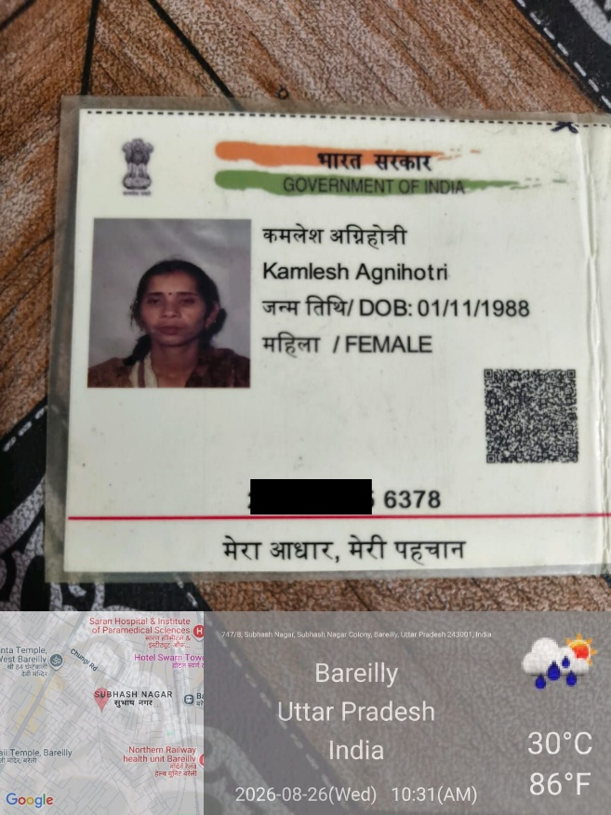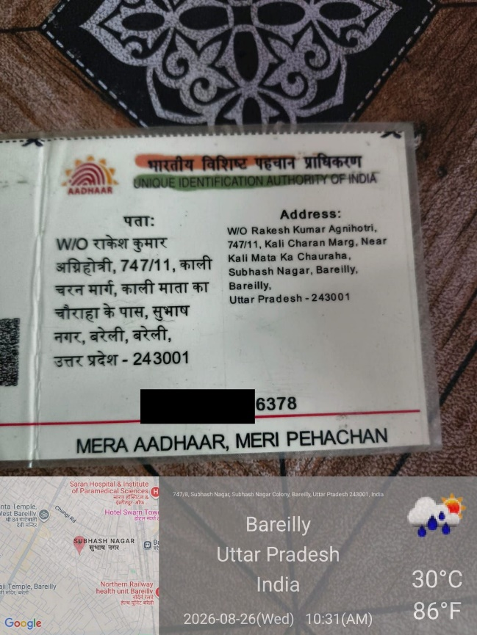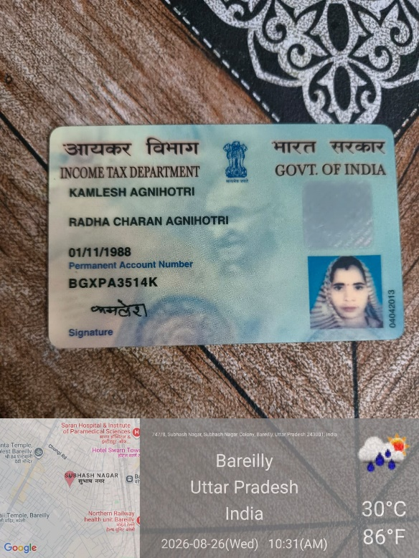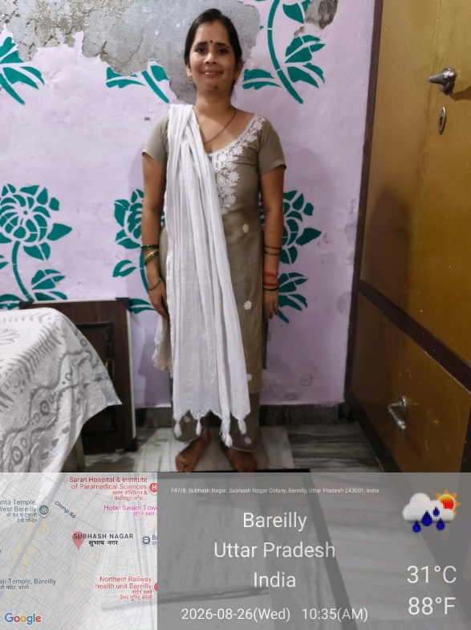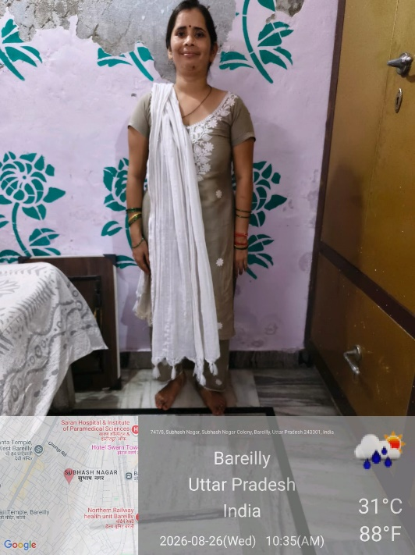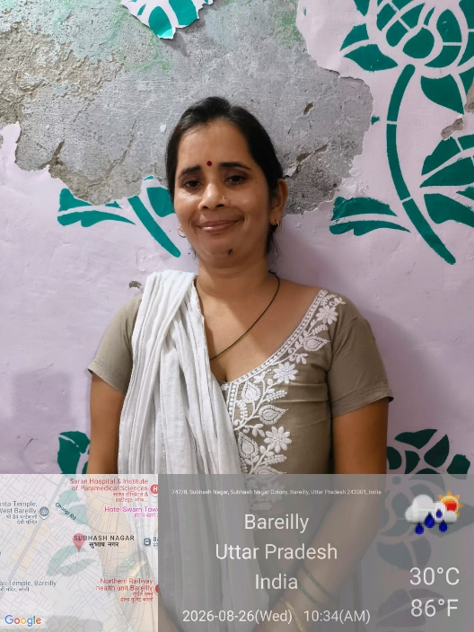
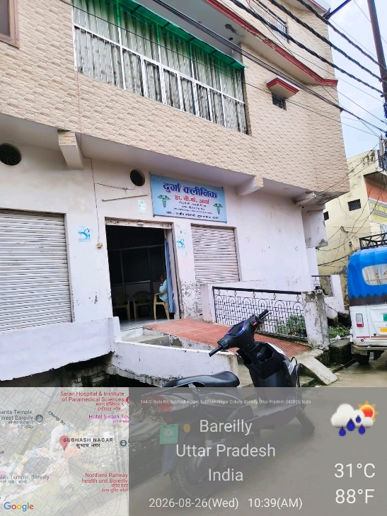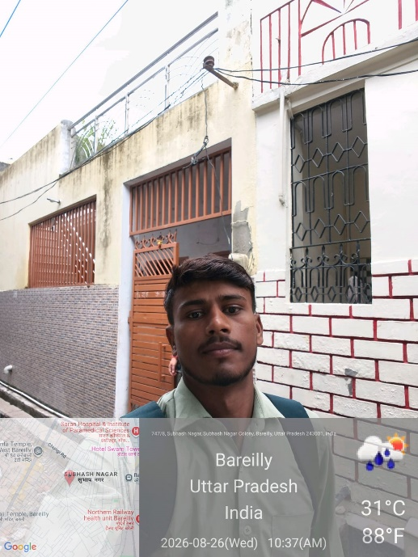


Seal of Investigation agency

